**VIETNAMESE - RUSSIAN FIELD INVESTIGATIONS OF NEARSHORE DYNAMIC AND SEDIMENT PROCESSES AT THE RED RIVER DELTA**

***Igor Podymov, P.P.Shirshov Institute of oceanology (Southern branch), podymov@coastdyn.ru***

***Ruben Kos’yan, P.P.Shirshov Institute of oceanology (Southern branch), rkosyan@hotmail.com***

***Tatiana Podymova, P.P.Shirshov Institute of oceanology (Southern branch), tpodymova@inbox.ru***

**Abstract. The Red river delta located in the Northern Vietnam is under constant threat from wave and high water level in the sea (especially during typhoons and severe northeast monsoons). Most of the Red river sediment is discharged into the sea through some different branches. In general, accumulation occurs in the vicinity of the branches, at a rate depending on the local sediment discharge of the branch. The most intensive accumulation is recorded at Day mouth and Balat mouth with the rate of about 10 meter per year. However, simultaneously with this accumulation, high rates of erosion has occurs at Hai Hau district - Nam Dinh province, threaten the low-lying land behind the sea dike system with the most population density of the Red river delta. In this context, the execution of a field survey on near shore wave, current and sediment transport in the Hai Hau beach during winter and summer monsoon season is the main objective of the Vietnam Russian investigations. Two Vietnam Russian joint projects (in 2011 and 2015) between Institute of Mechanics and the Southern Branch of P.P.Shirshov Institute of Oceanology were spending for studying dynamic of nearshore processes and sediment transport in coastal zone. Here presents some results of field investigations in coastal zone of Nam Dinh province.**

*Key words:* *Vietnam, coastal zone, sediment transport, dynamic processes, Nam Dinh province*

I. Introduction

Two named projects were carried out with the main objective to introduce new approaches for investigations of sediment transport and coastline evolution. These approaches to the problems are based on the investigations of physics of spatial and temporal change of suspended concentration and sediment transport caused by random waves in the near shore zone. Only the averaged time of processes have been studied in the traditional approach. For the new models of forecasting the spatial and temporal fluctuations of suspended sediments concentration and sediment transport under influence the different factors is necessary to receive a lot of new data in the testing area. New measurements have been performed to these purposes.

The Northeast (in winter) and Southwest (in summer) monsoons affect to the climate and marine dynamic regime of the Red river delta coastal zone. Respectively, two experiments have been organized on January 4-18, 2011, and on June 18-25, 2015.

II. Field investigations

Dynamic coastline areas of Vietnam are laying in the deltas of large rivers. Red river (Hongha river) is the second largest river of Vietnam. It forms a vast delta, known as «Red river delta». The delta plays an important role in the socio-economic development of the country. There are several scientific problems related to the dynamics structure of the delta. These include, trends in changes of the sediment load of the river, the process of the delta formation overall, the forecast extension (or recession) of delta areas into the sea. The nature of measures to protect ecosystems from the negative effects of hydrological and morphological processes depends from the chosen model of the delta dynamics.

The Red river delta has the typical triangular shape with the apex near the town of Viet Tri (150 km upstream from the mouth). The surface area of Red river's delta is 14.6 thousand km2. Length along the main river arm – 185 km. Seacoast of the delta has length about 200 km. River flow is entering to the sea by the nine of river's ramifications.

Mouth of the distributary of Ba Lat, is the main source of suspended sediments that are brought into the gulf of Tong King. About 34% of Red river's solid flow is transported through it. Full annual volume of suspended sediments transportation is about 81.583 million tons.

The movement of sediment is determined by the currents along the sea shore and by the waves influence. The direction of sediment transportation dominates from SW to NE during the summer monsoon. The direction is reversed during the winter monsoon. The waves are much stronger during this season. This is the reason the resulting annual coastal flux of sediment directed from SE to SW. Volume of suspended sediments delivered to the sea due to the erosion of the delta's coastal zone is 6.98 million tons/year.

The delta of Red river characterizes by a strong extension of the coast at the confluence of river's distributaries with the sea (Fig. 1). Areas of erosion are located between the mouths of the distributaries (Hai Hau beach, as example). Six estuaries of Red river delta’s distributaries are placing at this area. These are Cam, Van UC, Thai Binh, Tra Ly, Ba Lat, Ninh Co and Day. All of the estuaries are moved towards the sea gradually. The average intensity extension of the delta into the sea is 25 m/year. The largest growth fixed for the river of Day’s mouth (140 m/year). Estuary of river oriented to South. This reduces the wave loads and contributes to the accumulative processes in the estuarine zone.

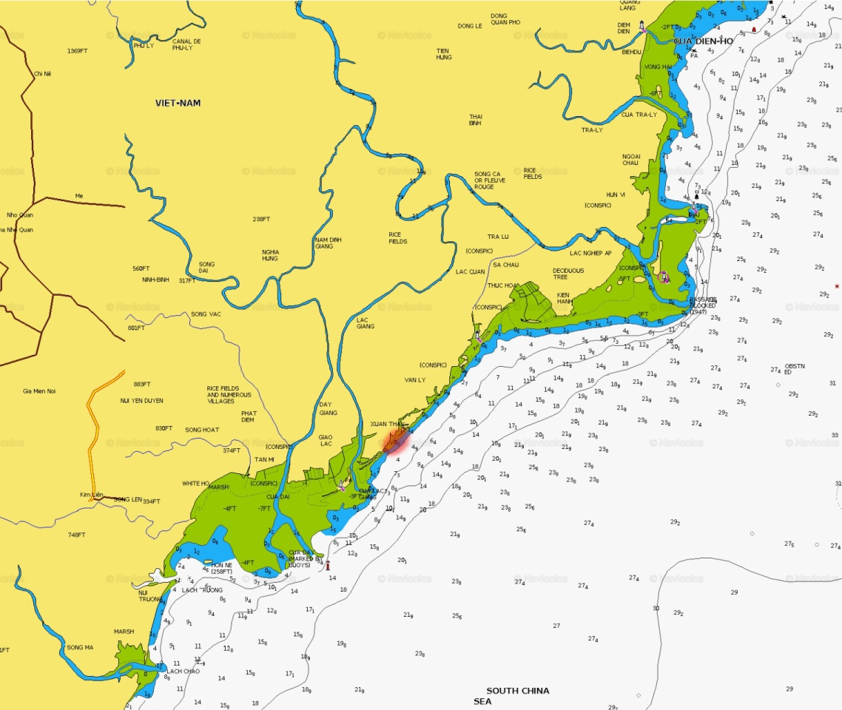

*Fig. 1. The southern part of Red river delta. The place of the field investigations have marked by red color.*

Length of erosion area for Hai Hau beach is 30 km, approximately. Here the shore is receding at a speed of 10 – 15 m/year for half a century.

Fig. 2 shows an example, illustrating the scale of destruction during the shore retreat.

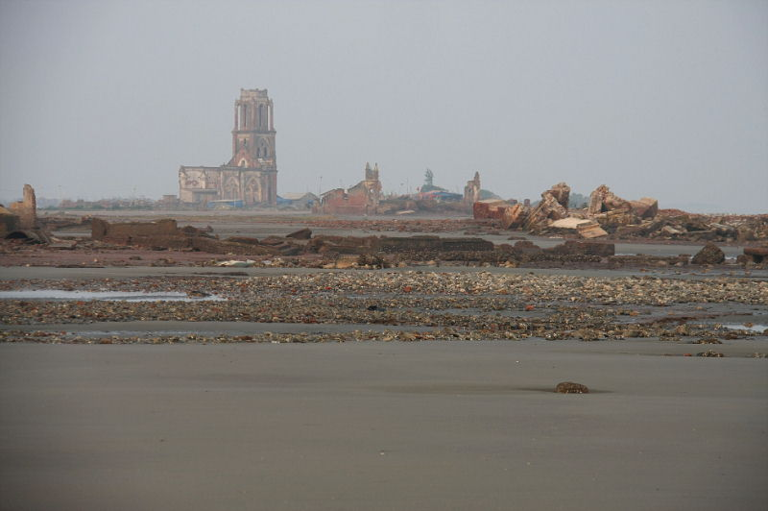

*Fig. 2. Here is intensively eroding fragment of Hai Hau beach. The region of Van Ly. Year 2011.*

Eroded areas gradually shifted to the South. For the Hai Hau beach selected four evolution periods:

* initial stage of the coast erosion between the mouth of Ba Lat and the village of Hai Dong (1912-1935);
* the most severe erosion of the shore between the villages of Hai Dong and Hai Trieu (1935-1965);
* the maximum erosion rate for the region of Hai Chinh - Hai Hoa (1965-1990);
* the maximum erosion rate between the villages of Hai Chinh and Thinh Long (1990-2005).

Analysis of long-term observations allowed us to conclude about the trend of increased volumes and the rate of erosion. Accumulation areas occurred only at the river mouths. The correlation between the extension of the Ba Lat river’s mouth towards the sea and the position of Hai Hau beach’s land with the most severe erosion been calculated. As determined, the most heavily erosion area is moving to southerly direction.

Anthropogenic factors, influencing to dynamics the delta of Red river:

* massive deforestation at the delta's plain, amplified erosion;
* the construction of dikes along the distributaries, which contributing to sediment deposition and increased river's beds;
* artificial removal of the riverbed's alluvium (for construction needs, as examples).

In the period of January 4-18, 2011 and June 16-28, 2015 in the place of Tinh Long an, Nam Dinh province at the South-China sea (Fig. 3) have been carried out field investigations.

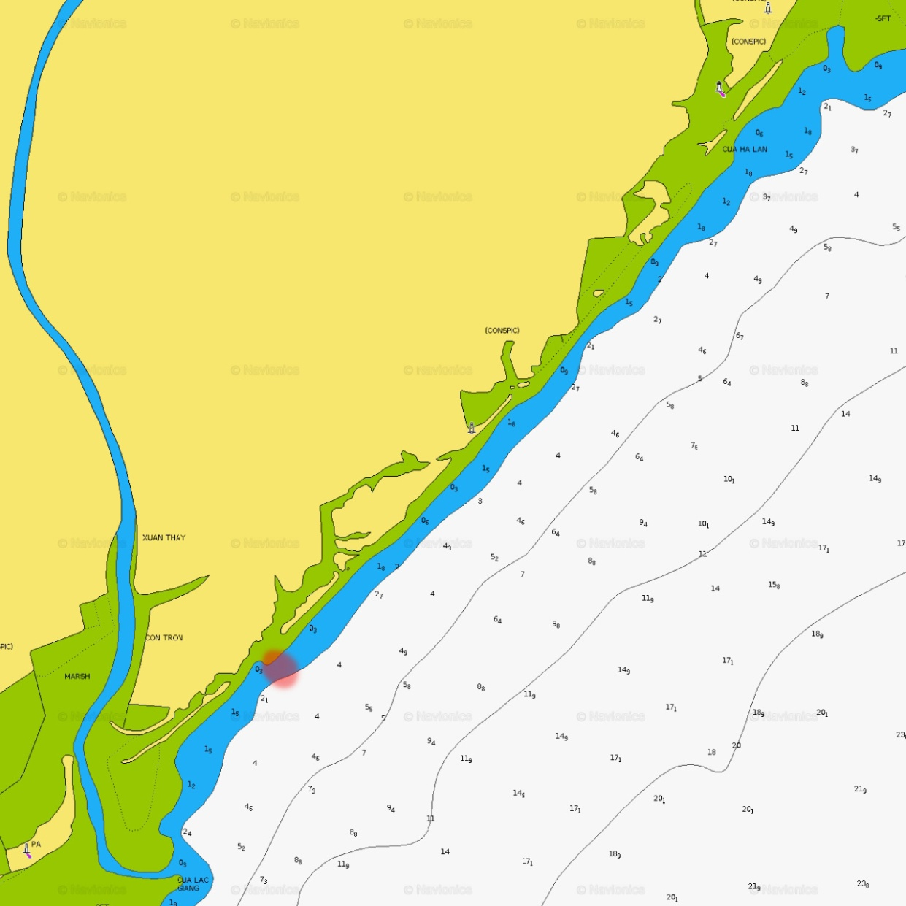

*Fig. 3. The coast area's scheme of the field investigations.*

III. Experiment set-up

*Equipment*

For the field investigations the following equipment was used (Fig. 4):

* optical turbidimeters (3 pieces), for the measurements of suspended sediments concentration (Fig. 4A);
* wave recorders GMU-2M (2 pieces, Year 2011), (Fig. 4B);
* wave and three components of current recorder VECTOR (Fig. 4C, Year 2015).

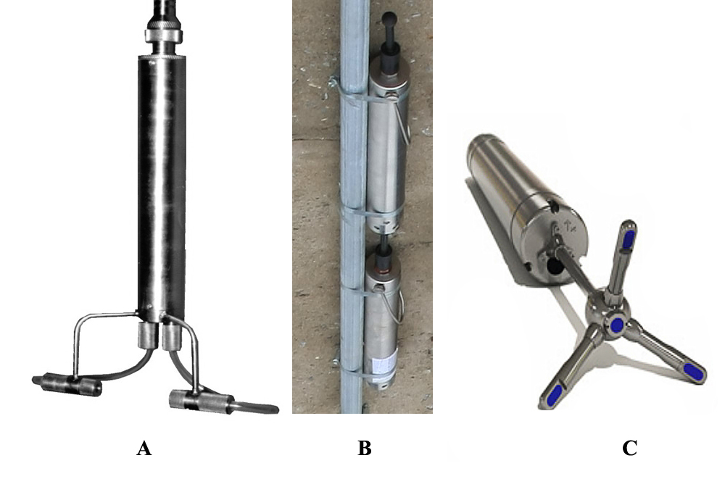

*Fig. 4. Optical turbidimeters (A); wave recorder GMU-2M (B); wave and current recorder VECTOR (C).*

Data from turbidimeters were entering into a personal computer through an external analog-to-digital converter E-140 with a frequency of 150 Hz between cycles of the survey. The time shift between reading the information of the neighboring channels was 6.6 ms. The bit width of each channel was 16 bit. Information from all turbidimeters was recording in a single file as ASCII codes for each cycle of measurements. In Fig. 5 shows the laboratory complex for collecting and record data from turbidimeters. Vector and GMU-2M were working in offline mode. Their data were recording to the internal memory.

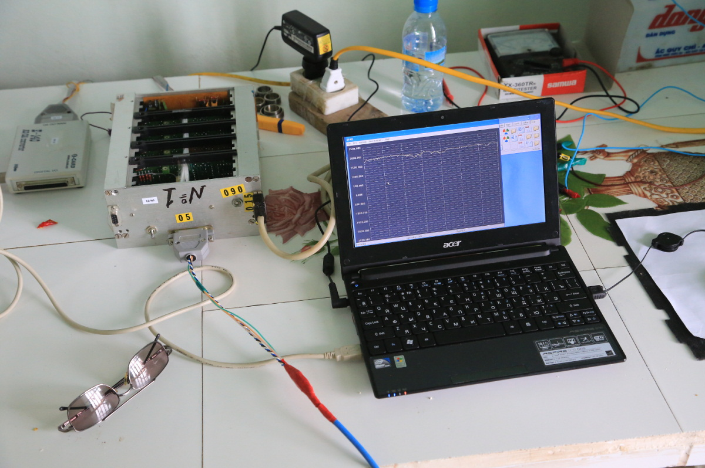

*Fig. 5. The laboratory complex for collecting and record data from turbidimeters.*

*Field measurements*

Gauges have been mounted at the steel stakes, which were installed at the distance 150m from the coast. Measurements of suspended sediments concentration were carried at the horizons 30, 60 and 90 cm from the sea bottom. Wave meters been installed about 45 cm from bottom. Mounting and removing the measuring equipment were carried out during low tide. General view to measuring polygons is shows in Fig. 6.

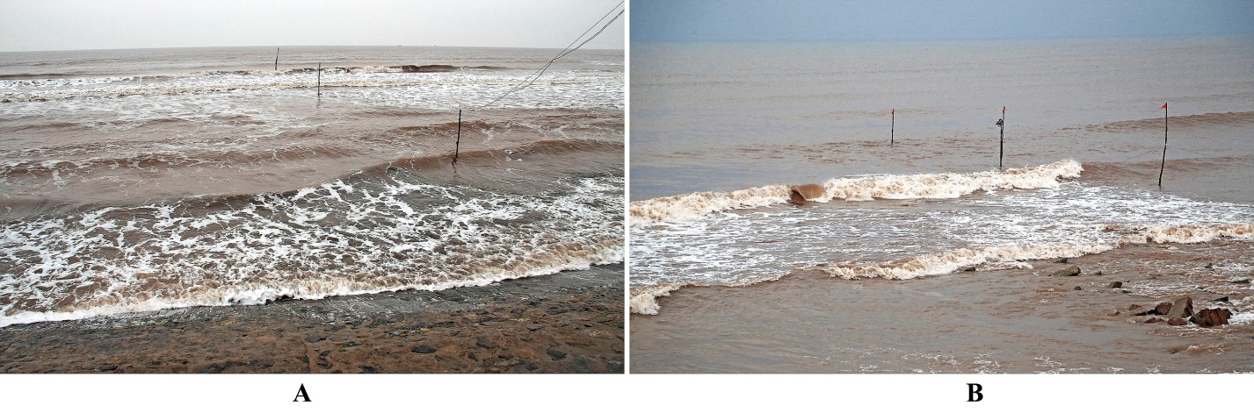

*Fig. 6. Areas of the field investigations: A – Year 2011; B – Year 2015.*

Calibration of the turbidimeters has been performed with samples of sand taken from the place of measurement. GMU-2M and Vector had the calibration of manufacturers. Garmin 62stc fixed GPS tracks of movements along shore protection structures. Coordinates of objects of interest recorded in the metadata of photos and video files by the navigation module of Canon GP-E2. Sand granulometric analysis made by sifting method. Sand composition presented in Fig. 7.

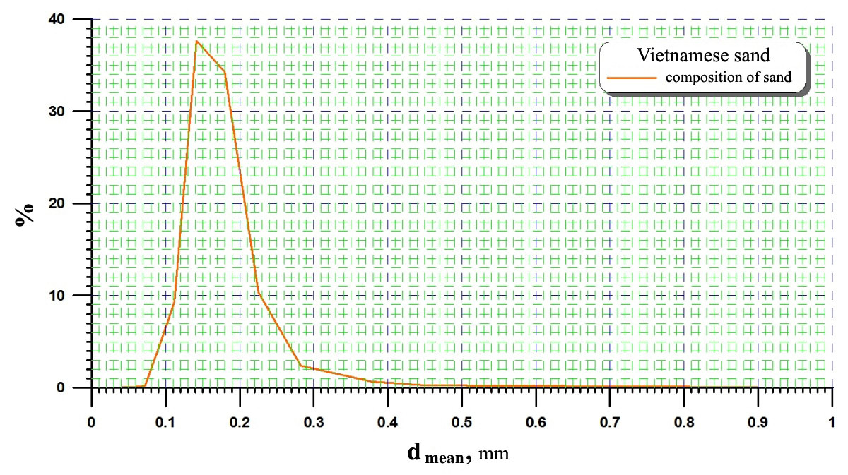

*Fig. 7.* *Vietnamese sand granulometric composition.*

As a first approximation, the mineralogical composition of sand been evaluated by viewing samples under an electron microscope. In Fig. 8A – 8D are photos of sand samples with different magnification.

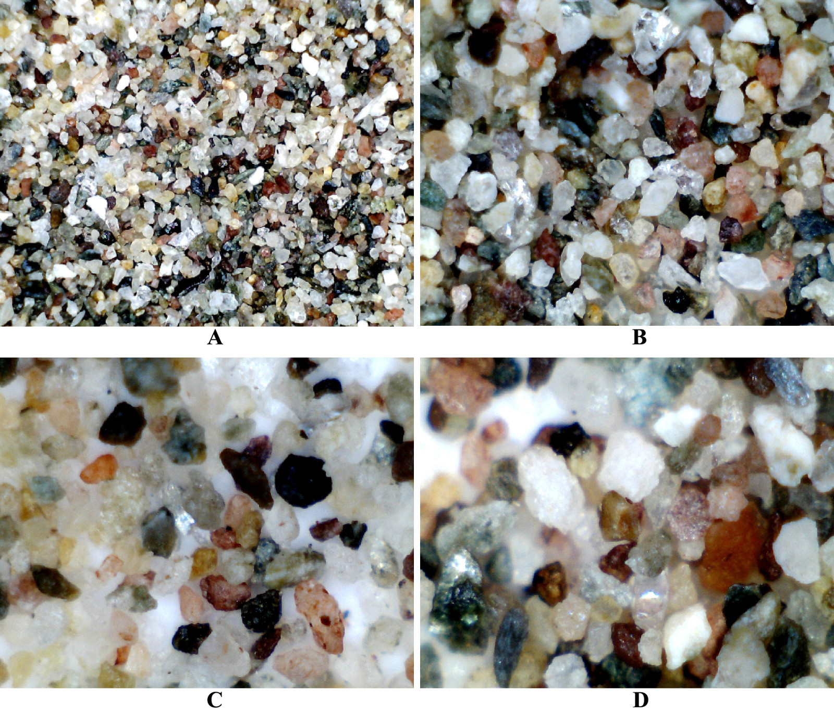

*Fig. 8.* *Photos of sand samples with different magnification: A) X20; B) X200; C) X400; D) X800. If the scale is X800, physical size along X-axis is 1 mm.*

The components of geological materials, captured by the water flow at the upper river, enter into the composition of the sediments, transported by the Red river. The water has a yellow color already in the upper reaches of the river (Fig. 9).

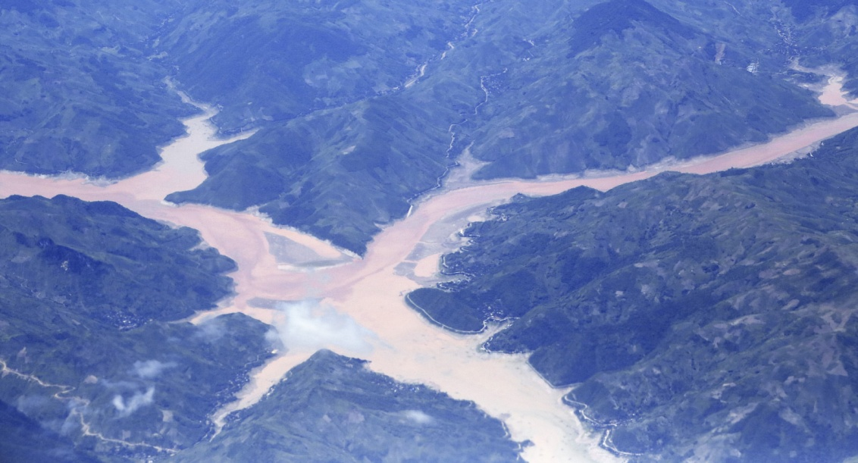

*Fig. 9. Upper of Red river.*

IV. Results of field investigations

During two experiments been performed more than 30 series of measurements. The recording duration for one series of measurement was 0.5 – 1.5 hours. Full duration of records for the suspended sediment concentration is 22 hours. Graphics (see Fig. 10, Fig. 11, Fig. 12) show the changes of suspended sediment concentration at the horizons of 30, 60 and 90 cm from the bottom for different stages period of flood and ebb.

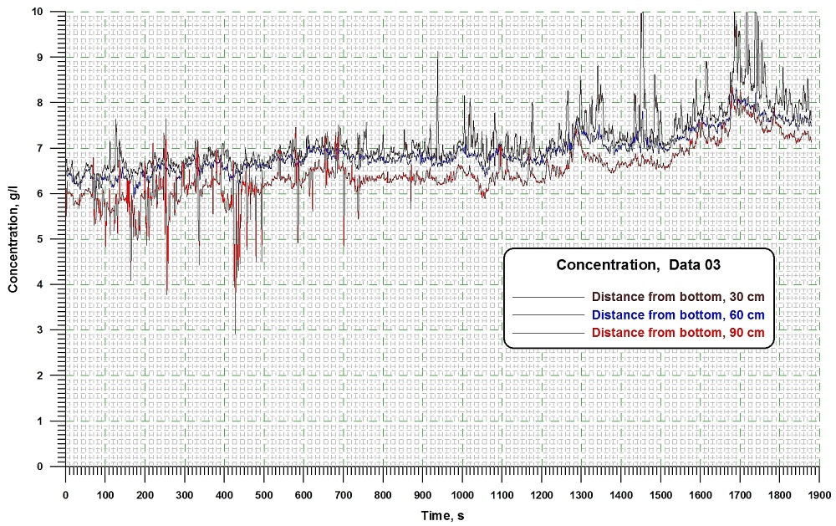

*Fig. 10.* *Graphics of suspended sediment concentration changes at the horizons of 30, 60 and 90 cm from the bottom in the initial stage of tide. Year 2015.*

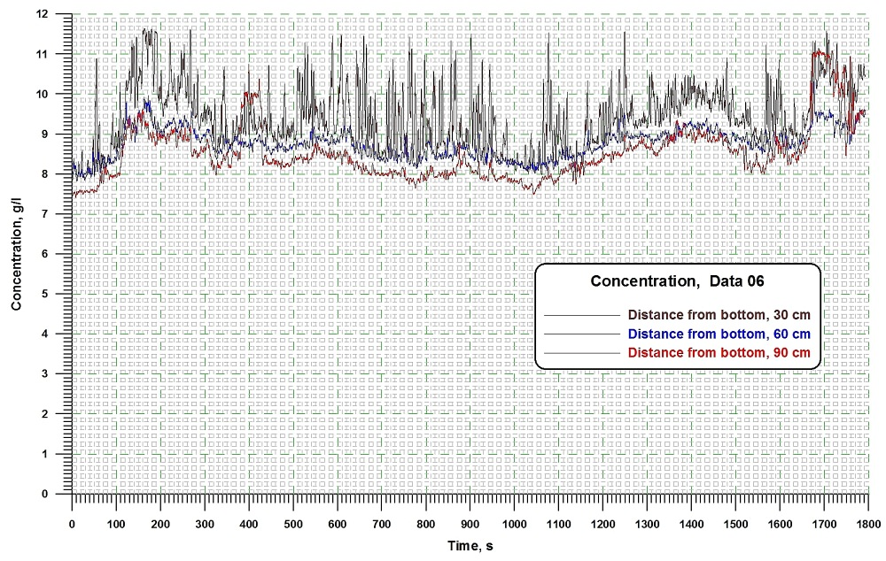

*Fig. 11.* *Graphics of suspended sediment concentration changes at the horizons of 30, 60 and 90 cm from the bottom in a fourth stage of tide. Year 2015.*

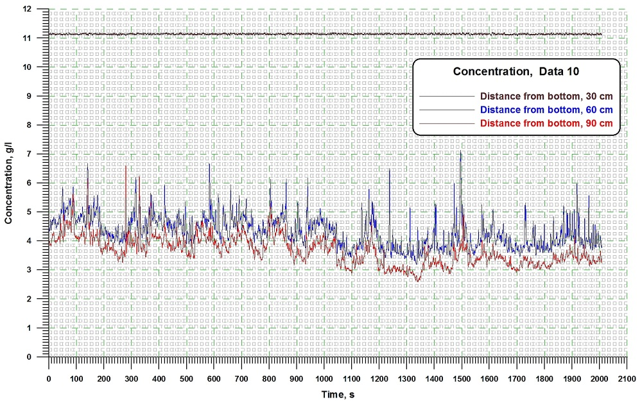

*Fig. 12. Graphics of suspended sediment concentration changes at the horizons of 30, 60 and 90 cm from the bottom in a stage of maximum tide. Year 2015.*

Table 1 shows the concentrations of suspended sediment for 2015 Year measurements.

Table 1. Summary table of the average and maximum values of suspended sediment concentrations for 2015 Year measurements

|  |  |  |  |  |  |  |  |  |  |  |
| --- | --- | --- | --- | --- | --- | --- | --- | --- | --- | --- |
| Record number | Time | | Suspended Sediment Concentration, g/l | | | | | | | |
| start | finish | 30 cm | | | | 60 cm | | 90 cm | |
|  | | | mean | | max | | mean | max | mean | max |
| June 23, 2015 | | | | | | | | | | |
| adc_data_01.dat | 05-12 | 06-06 | 0.84 | 2.7 | | - | | - | - | - |
| adc_data_02.dat | 07-00 | 08-00 | 1.97 | 6.1 | | - | | - | - | - |
| adc_data_03.dat | 09-27 | 10-00 | 7.19 | 9.84 | | 6.90 | | 8.40 | 6.48 | 8.46 |
| adc_data_04.dat | 10-57 | 11-32 | 8.94 | 11.34 | | 8.39 | | 9.71 | 8.32 | 10.20 |
| adc_data_05.dat | 11-57 | 12-32 | 9.71 | 11.54 | | 8.89 | | 10.82 | 8.82 | 11.65 |
| adc_data_06.dat | 13-00 | 13-32 | 9.44 | 11.51 | | 8.77 | | 10.31 | 8.53 | 11.06 |
| adc_data_07.dat | 14-00 | 14-02 | 11.94 | 12.14 | | 10.04 | | 10.93 | 9.80 | 10.31 |
| adc_data_08.dat | 14-04 | 14-35 | 12.18 | 12.36 | | 9.82 | | 12.13 | 7.29 | 7.79 |
| adc_data_09.dat | 14-43 | 15-21 | 11.94 | 12.28 | | 10.74 | | 12.10 | 8.82 | 9.96 |
| adc_data_10.dat | 16-55 | 17-30 | 11.14 | 11.2 | | 4.33 | | 7.16 | 3.66 | 6.65 |
| adc_data_11.dat | 19-04 | 19-38 | 10.95 | 11.08 | | 3.91 | | 7.94 | 3.19 | 4.34 |
| adc_data_12.dat | 20-56 | 21-36 | 9.83 | 9.85 | | 3.62 | | 8.99 | 2.94 | 4.58 |
| adc_data_13.dat | 23-08 | 00-30 | 10.46 | 10.54 | | 4.44 | | 11.04 | 3.31 | 6.65 |
| June 24, 2015 | | | | | | | | | | |
| adc_data_14.dat | 01-00 | 01-30 | 10.38 | 10.40 | | 5.29 | | 10.94 | 4.69 | 6.95 |
| adc_data_15.dat | 02-57 | 03-32 | 10.57 | 10.58 | | 5.03 | | 11.04 | 4.29 | 7.34 |
| adc_data_16.dat | 05-39 | 06-20 | 11.02 | 11.08 | | 7.91 | | 11.92 | 7.12 | 10.56 |

*Average data of the research*

Period of flood and ebb is about 12.5 hours for this region. The sea level changes over one tidal cycle is 2-2.5 m. During typhoons, changes of sea level can reach a height of 5.5 m. This may lead to catastrophic destruction. An example of destruction illustrated in Fig. 13. Here shows the building used for installation of scientific equipment in Year 2015.

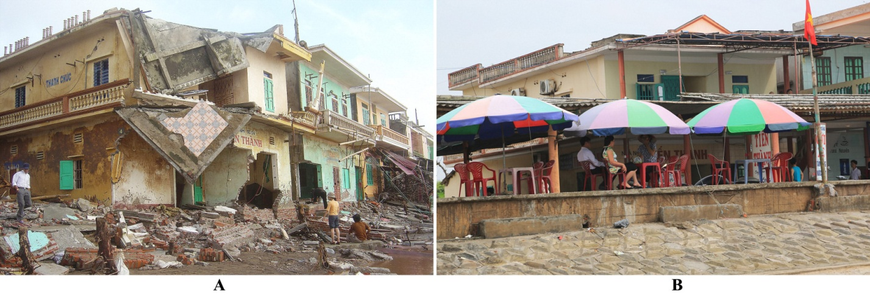

*Fig. 13. Here is the building used for installation of scientific equipment in Year 2015.*

*A – 28.09.2005, after the typhoon; B – 23.06.2015, scientific equipment installed at the first floor.*

During the investigations, have been obtained the following average data:

* The range of wave heights in the open sea is 3-3.5 m. The height of the waves in the breaking zone (at the point of measurement) is 0.7-0.8 m.
* *The horizon of 30 cm from bottom. Winter period.* Average concentration of suspended sediments is 6 g/l, maximum – 9.7 g/l. *Summer period.* Average concentration of suspended sediments is 9.28 g/l, maximum – 12.36 g/l.
* *The horizon of 60 cm from bottom. Winter period.* Average concentration of suspended sediments is 5.7 g/l, maximum – 8.8 g/l. *Summer period.* Average concentration of suspended sediments is 7 g/l, maximum – 12.13 g/l.
* *The horizon of 90 cm from bottom. Winter period.* Average concentration of suspended sediments is 1.8 g/l, maximum – 2.4 g/l. *Summer period.* Average concentration of suspended sediments is 6.2 g/l, maximum – 11.65 g/l.

Measurement show, during the summer monsoon volume of transported sediments, approximately 75% higher than in the winter. This may be the result of flooding period, which occurs in June-October.

Along the shore transportation of suspended sediments is determined by the influence of waves and along the shore currents. During the winter monsoon waves is much stronger than during the summer monsoon [1]. This is the reason the average annual flow of sediments has NE-SW direction. Detailed results of the investigations presented in [2] and [3].

V. Conclusions

The experiments took place at one of the least studied sites of the Vietnam coast. Measurements of fluctuations of the suspended sediments concentration with the help of modern instruments have been making in Vietnam for the first time.

Summarizing the results of researches, we can say.

Data on geomorphology and morpho - lithodynamic the coastal zone of the studied coast have allowed identify within it a relatively isolated natural lithodynamic system, to explain their formation and to trace evolutionary changes. For the delta of Red river, areas of accumulation are located at river's mouths. Areas of intensive erosion are located between the mouths of the distributaries. The main factors determining the dynamics of the delta’s seacoast are wave and tidal processes, onset sea level fluctuations. Erosion processes are likely to worsen with the reduction of solid flow. There are several scientific problems related to the dynamics structure of the delta. These include, trends in changes of the sediment load of the river, the process of the delta formation overall, the forecast extension (or recession) of delta areas into the sea. Based on such data is possible to build a forecast concerning the processes of accumulation and erosion at the delta's areas.

A combination of new and existing data will allow to obtaining interesting results and new way to highlight the issue of coastal zone management.

VI. References

[1] Nguen Manh Hung, “Coastline and river mouth evolution in Vietnam,” Hanoi: PHST, 2012, 369 p.

[2] Nguyen Manh Hung, R. D. Kosyan, I. S. Podymov, V. A. Sokolov, “A Vietnam – Russia field survey for studying of the near shore dynamic and sediment processes at the Red River Delta,” *The proceedings of the International Workshop on “International cooperation on the investigation and research of marine natural resources and environment*”, Hanoi: 2011, pp. 152-162.

[3] Nguyen Thi Viet Lien, Nguyen Manh Hung, R. D. Kosyan, “Vietnam – Russia joint projects on near shore dynamics and sediment transport,” *Proceedings of “Scientific Workshop on “Progress and Trends in Science and Technology”*, Hanoi: 2016, pp. 60-73.